EU/EC DECLARATION OF CONFORMITY



Declaration number: 25EECS04050C0371

This Declaration of Conformity (DoC) is issued under the sole responsibility of the manufacturer.

Manufacturer: S-Cube s.r.o.
Address: Krajánkova 3176/2, Záběhlice, 141 00 Praha 4, Czech republic

Product: 140W GaN TFT Display Charger PW21, 2x USB-C, 1x USB-A
Product code: MO-140WDCH-PW21
Models: PD-136, PD-136UK, PD-136PTUK, PD-136UKxy, ACK303, HT-409, MCU523, JD-WCxyz, PD-136EU, PD-136PTEU, PD-136EUxy, ACE303, CH-1203, PD-136-UK, PD-136PT-UK, PD-136-UKxy, M-Ai-G140W-V7, PD-136-EU, PD-136PT-EU, PD-136-Euxy
x, y, z is 0-9, indicating a different customer code, which does not affect the safety and electromagnetic compatibility of the product
Brief description: Charger with GaN technology. Technologies PD for 2xUSB-C and QC3 for USB-A deliver up to 140W of power. Charging power is displayed on TFT display. Charger offers flexible connectivity, while its compact size, lightweight construction ensure safety and convenience at home or on the go.

The object of the declaration Directive 2014/30/EU
described above is in conformity
with relevant European Union
harmonization legislation:
The relevan harmonized EN 55032:2015+A11:2020+A1:2020
standards are applied EN 55035:2017+A11:2020
to which conformity EN IEC 61000-3-2:2019+A1:2021+A2:2024
is declared: EN 61000-3-3:2013+A1:2019+A2:2021
This product carries the CE mark:

Signed:
Name and function: Rudolf Chvátal, director
Date and Place of Issue July 23, 2025 – Prague
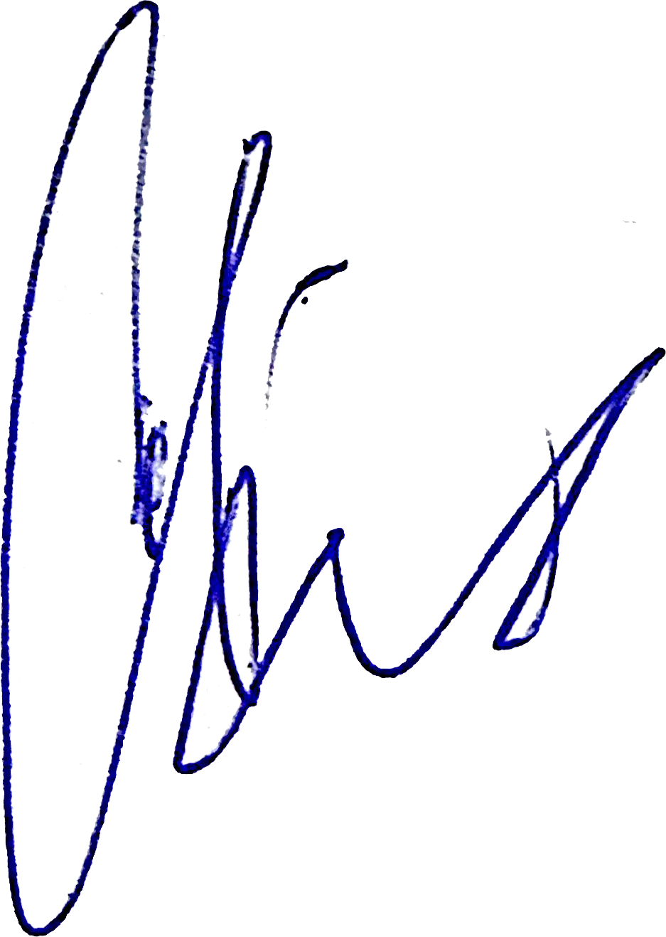

Signature:

