EU/EC DECLARATION OF CONFORMITY



Declaration number: CA24050546-E-000

This Declaration of Conformity (DoC) is issued under the sole responsibility of the manufacturer.

Manufacturer: S-Cube s.r.o.
Address: Krajánkova 3176/2, Záběhlice, 141 00 Praha 4, Czech republic

Product: 65W GaN LED Display Charger PW2, USB-C Cable, 1x USB-C, 1x USB-A
Product code: MO-65WDCH-PW2
Models: CH042, CH042-PQ, CH042-MH, CH042-H01, CH042-H02, CH042-H03,
CH042-CCA, CH042-65W, CH042L, CH042L-PQ, CH042L-CCA, WP-U39
Brief description: Charger with GaN technology. Technologies PD for built-In 1x USB-C cable and 1xUSB-C and QC3 for USB-A deliver up to 65W of power. Charging power is displayed on LCD display. Charger offers flexible connectivity, while its compact size, lightweight construction ensure safety and convenience at home or on the go.

The object of the declaration Directive 2014/30/EU
described above is in conformity
with relevant European Union
harmonization legislation:
The relevan harmonized EN 55032:2015+A11:2020+A1:2020
standards are applied EN 55032:2015+A11:2020
to which conformity EN 55035:2017+A11:2020
is declared: EN IEC 61000-3-2:2019+A1:2021
EN 61000-3-3:2013+A2:2021

This product carries the CE mark:

Signed:
Name and function: Rudolf Chvátal, director
Date and Place of Issue July 16, 2024 – Prague
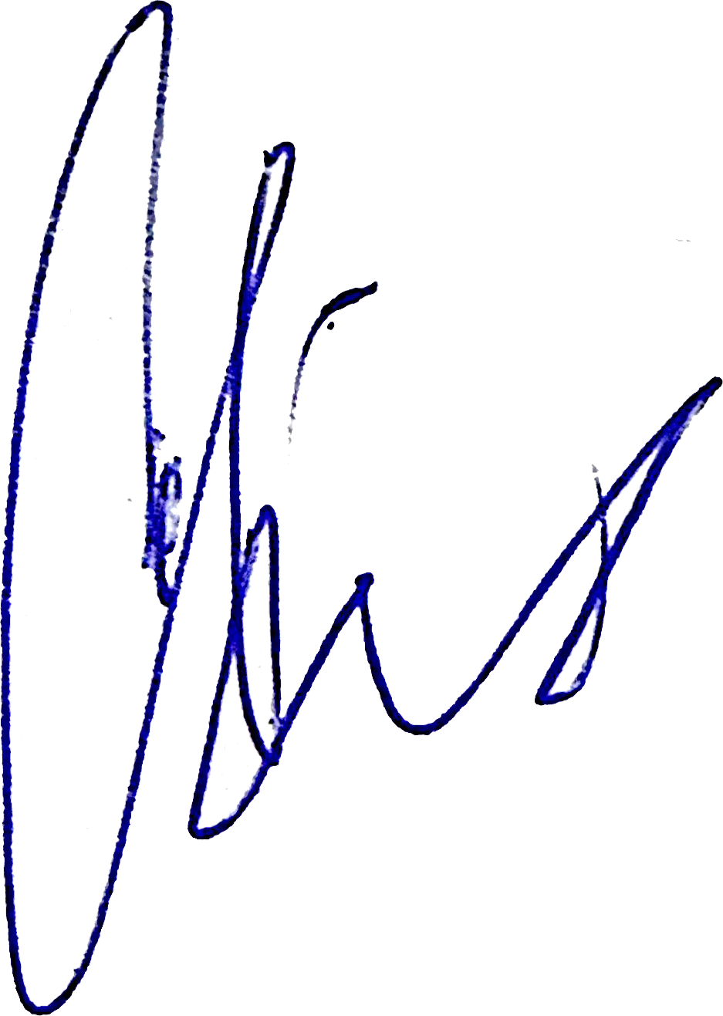

Signature:

